EXPERIMENT 1.1.1 – Area of Circle
NIRMAYEE S. KADAM PRN: 25070521134 C1
Algorithm:
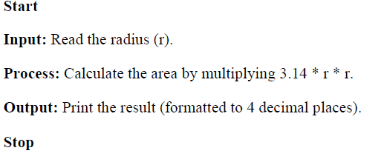

Flowchart:
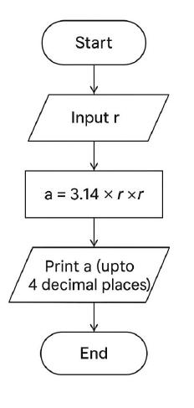

Code:
